FIN 608 Project 1

Group 2

# 1 Background

The total asset growth anomaly indicates a negative relationship between return on equity and the annual growth rate of the total asset in the subsequent one year. Which means, firms and companies with relatively large rate of total asset growth are expected to produce relatively poor return on equity in the next year or the next given time period. The given set of stocks contain rank of annual total asset growth among the stocks. It contains 300 non-financial stocks with highest growth of total asset in the previous year, and another 300 non-financial stocks with lowest growth of total asset. The former subset would be treated as the pool of short candidates, while the later subset would be treated as the pool of long positions. Based on previous finding, the TAGA filter provides us two portfolios each contains 300 stocks.

In this project, we aim to further reduce the number of stocks within each portfolio and establish two new portfolios which contain 50 chosen short candidates and 50 chosen long candidates respectively. The stocking in the set of long (or short) candidates have the same weights that would remain unchanged during the whole period. This setting for stocks from short candidates is the same. The initial endowment of the portfolio is $500K with an initial short position of $3K on each short candidate and an initial long position of $13K on each of the 50 long candidates, inclusive all transaction cost.

# 2 Data and Algorithm

Since our goal is to trim the size of the given two portfolios from 300 to 50, a new filter could be designed. Also, based on the fact that our candidates are non-financial firms, accounting factors could act as relatively good indicators of their performance. Therefore, we examined the following factors for long and short candidates respectively.

## 2.1 Long Position Candidates

The followings are chosen factors along with the reasons why we choose them.

### 2.1.1 Total Asset Change

Data: (2018 total asset - 2017 total asset) / (2017 total asset)

A huge total asset reduction, say greater than 80%, may indicate a major loss or a reorganization, which creates uncertainty without knowing the firm’s future strategy. Hence, these candidates are excluded to reduce the risk of the portfolio.

### 2.1.2 Research and Development Cost / Total Asset

Data: (2018 Research and Development Cost) / (2018 Total Asset)

The ratio of (Research and Development Cost) / (Total Asset) indicates the percentage of cost of research and development in total asset. If this ratio is relatively high, it would show that the firm invests a lot of funds on research. The firm with this trait is more likely to have promising future than those with relatively less Research and Development expenditure. On the other hand, we believe that the Research and Development Cost of a certain company should not exceed the asset too much. If this ratio is too high, it means that the firm may spend too much on R&D, which indicates that the firm may not have enough fund for daily operating. Also, it is possible that the research output could not match the money input, which may cause some unforeseen risks in future. In all, firms with relatively higher ratios would have greater chances to develop in future, and higher probabilities for their market value to move up. Hence, excluding stocks with relative low and extremely high R&D / A would be a reasonable choice for a long position.

### 2.1.3 The Change of Debt / Assets Ratio

Data: (2018 Debt) / (2018 Assets) – (2017 Debt) / (2017 Assets)

The change of Debt / Assets Ratio indicates that the movement of percentage of debt over assets. In other words, the percentage of equity over assets increases if the change of ratio is negative. Since the ratio of E / A increases, we would consider that the equity’s value tends to increase, which means the probability of increasing returns would be relatively higher compared with those with positive change of D / A Ratio. Hence, we would exclude those stocks with positive change of D / A Ratio.

### 2.1.4 Current Ratio

Data: (2018 Current Assets) / (2018 Current Liabilities)

The current ratio is a liquidity ratio that measures a company's ability to pay short-term and long-term obligations. A company with a low current ratio may not have enough capital instantly to meet its short-term obligations if they were all due at the same time. Since a high current ratio indicates the company should be able to remain solvent in a short-term period, we prefer those stocks with high current ratio.

## 2.2 Short Position Candidates

For the short position candidates, we would focus on the following factors, and the reasons why we choose them come up respectively.

### 2.2.1 Decrease in Price in the Past Quarter

Data: (2018 Price)

If the price of a certain stock has decreased too much, like 90% in the past three months, we will remove it from the short candidates. We are worried that a large drop in the past may cause the stock to be undervalued. Besides, the risk of retaliatory price rebound are high relative to the probability of decreasing return.

### 2.2.2 EPS

Data: (2018 EPS) and (2017 EPS)

Earnings per share (EPS) is the portion of a company's profit allocated to each share of [common stock](https://www.investopedia.com/terms/c/commonstock.asp). Earnings per share serves as an indicator of a company's profitability. If EPS is too low, it means that the company may have difficulty in generating profits. Hence, we choose those firms with low EPS as short candidates.

### 2.2.3 Price/Earing Ratio

Data: (2018 P/E Ratio) and (2017 P/E Ratio)

The price-earnings ratio (P/E ratio) is the ratio for valuing a company that measures its current share price relative to its per-share earnings. The price-earnings ratio is also sometimes known as the [price multiple](https://www.investopedia.com/terms/p/pricemultiples.asp) or the earnings multiple. In general, a high P/E indicates either that a company may currently be overvalued or that investors are expecting higher earnings growth in the future. Hence, we prefer those stocks with relatively high P/E Ratio.

### 2.2.4 The Change of Debt / Assets Ratio

Data: (2018 Debt) / (2018 Assets) – (2017 Debt) / (2017 Assets)

The reason is similar to that in long position part, while the criterion would be the opposite. We exclude those stocks with negative change of D / A Ratio.

### 2.2.5 Current Ratio

Data: (2018 Current Assets) / (2018 Current Liabilities)

The reason is similar to that in long position part, while the criterion would be the opposite. We exclude those stocks with high Current Ratio.

### 2.2.6 Administration Cost

Data: (2018 Administration Cost) / (2018 Assets)

We use Administration Cost / Assets as an indicator to pick some candidate stocks. We will use this factor to extract some firms with extreme conditions. That is, if the administration cost is too high relative to assets, we think this will make a negative effect on the growth of a company and thus we short stocks like this.

# 3. BACK TEST

Portfolio performance is tested starting from single factor filters to multi-factor filters. For single factor filters, we only provide filtering criterion, results of return, and comparisons with benchmark which is the 300-stock portfolio return (that is, if it is a long candidate filter, we would compare its return with the return of portfolio containing all 300 long candidates; and the same comparison would be done for short candidates); for multi-factor filters, a more thorough explanation would be provided.

One thing needs to specify is that, for single factor filters, we just aim to find out whether some specific filters are valid for prediction purpose. Therefore, the result may yield a portfolio of more than 50 stocks.

For multi-factor filters, we will combine the valid factors and design a new threshold to constrain the candidate number to exact 50. The threshold of factors is determined according to the combination of the number of stocks that we needed, parameter optimization and some artificial arts.

## 3.1 Long Portfolio Single Factor Test

For long portfolio, the benchmark return is -12.33%. For the following factors, if the filter results in a portfolio of return higher than -12.33%, we would consider it as an applicable factor; otherwise we would consider it inapplicable.

### 3.1.1 Research and Development Cost / Total Asset

We picked the stocks which have Research and Development Cost/Total Asset ratio greater than 10%. There are 156 stocks remaining in total with an average return of -0.105, larger than benchmark. It shows this ratio is a valid factor.

### 3.1.2 Change of D/A Filter

We remove the stocks that have positive delta D/A ratio from the long portfolio. For those stocks do not have delta D/A ratio or equals to zero, we also remove them. There are 176 stocks remaining in total and the average return is -0.13 over the last quarter, lower than benchmark. It shows this filter is not helpful on choosing stocks.

### 3.1.3 Current Ratio

We remove all the stocks whose current ratio are less than 4. For the remaining 96 stocks, the average return is -0.095, which is greater than that of benchmark. It shows this filter is valid for choosing stocks.

## 3.2 Short portfolio Single Factor Test

For short portfolio, the benchmark return is -12.80%. For the following factors, if the filter results in a portfolio of return lower than -12.80%, we would consider it as an applicable factor, otherwise we would consider it inapplicable.

### 3.2.1 Change of D/A Filter

We remove the stocks that have negative delta D/A ratio from the short portfolio. For those stocks that do not have delta D/A ratio or equals to zero, we also remove them.

There are 180 stocks remaining in total and the average return for this portfolio is -0.126 over the last quarter, higher than the benchmark. It shows this factor doesn’t help to choose stocks.

### 3.2.2 EPS

If EPS is larger than -2, then we will remove the stocks out of the short portfolio. There are 66 stocks in total and the return of the portfolio in the last quarter is -22.6%. We can see that this factor almost doubles the return of the portfolio. Thus, it can be used to choose short positions candidates.

### 3.2.3 Administration Cost

If Administration / Assets is larger than 0.5, we will choose to short stocks like this. There are 112 stocks remaining and the average return is -10.6%. It’s higher than the benchmark so we think it as an invalid filter.

### 3.2.4 Current Ratio

We set the threshold to be 2, and we remove all the stocks that are greater than 2. For the remaining 114 stocks, the average return is -0.16 which is lower than the benchmark. Thus, we think it is a valid filter.

## 3.3 Final Long Portfolio

The final long portfolio is created based on the following steps.

1. Remove all stocks with asset growths less than -0.8.

2. Remove all stocks with current ratios less than 4.

3. Remove all stocks whose (Research and Development) / (Assets) ratio are less 20% or greater than 80%.

4. Remove 2 stocks with the highest return and 2 stocks with the lowest return. Since they would have relatively higher volatility and less stable compared with others.

## 3.4 Final Short Portfolio

The final short portfolio is created based on the following steps.

1. Remove all stocks with current ratios greater than 2.

2. Find 54 stocks with lowest EPS.

3. Remove 2 stocks with highest return and 2 stocks with lowest return. Since they would have relatively higher volatility and less stable compared with others.

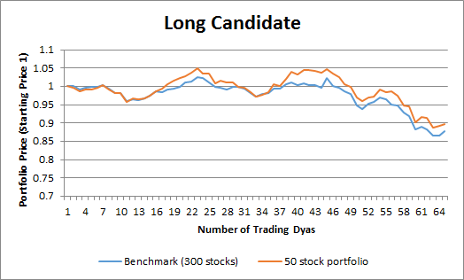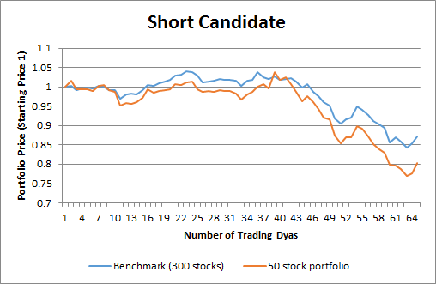

# 4. Results

With a benchmark which is equal weighted return of initial candidates (300 long and 300 short stocks chosen by TAGA strategy) for long and short positions in a 130/30 fund, we plotted the blue line with a final holding period return of -12.18%. Based on our previous long portfolio and short portfolio, we created another 130/30 fund, which is also plotted as follows in orange, with a final holding period return of -7.50%.

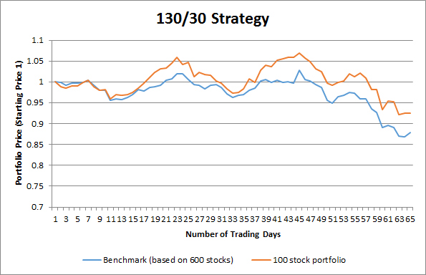

The result is rather straightforward. Our 100 stock portfolio beats the benchmark almost all the time during the chosen timeframe.